Deputy Director of Custom,

Sri Lanka Custom,

Dear sir,

**To explain the content in the package ordered via e commerce manufacturer over internet**

Package I have imported contains samples of programmable STEM minicomputers I have designed to educate children about climate and weather. Below images show what’s inside the package,

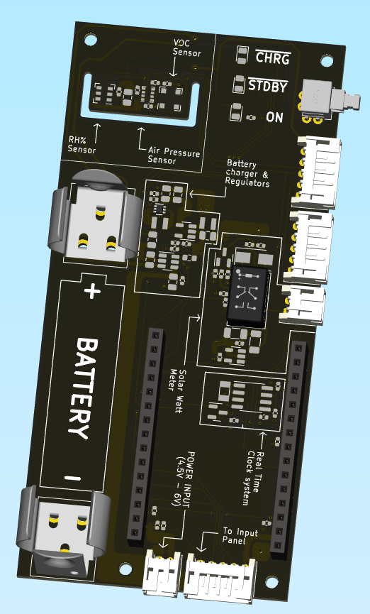

Sample of single board computer Board – Educational device to teach electronics, Programming, and computing.

Below HS codes can be applied

**HS CODE – 8471.30**

**8471.30.90** or

**8471.41** or

**8471.41.90** or

Use a wire to connect.

